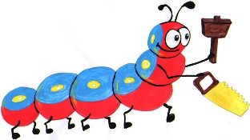

Lyng Primary School Knowledge Organiser

Design Technology



Viking Bread (History)

Year 6

Topic: DT

Autumn

|  |  |
| --- | --- |
| What Goldilocks and Step On words will I use? | |
| **Spelling** | **Defintion** |
| Cookbook | A book which contains recipes to make various dishes or foods. |
| Equipment | Items and objects which are needed to complete a task. |
| Farm | Land or water used to produce crops or raise animals for food. |
| Flavour | How food or drink tastes (e.g sour, sweet, bitter, salty). |
| Imperative verb | Also known as ‘bossy verbs’ because they tell you what to do, (e.g bake, grill, add, heat). |
| Ingredients | Items that make up a mixture e.g foods that make a recipe. |
| Method | A way of carrying out a certain process, following a list of instructions. |
| preparation | Belonging to a certain group of people in a particular country. |
| processed | The process of getting ready to make something. |
| recipe | When foods are passed through multiple processes in a factory to change or preserve it so it keeps for longer. |



**Design Brief for pupils:**This is heavy bread, most likely what you read about when you come across references to “brown bread” in history or historical fiction books. While I wouldn’t recommend it as a substitute for your Italian bread, it was really good as a snack – warm from the oven and drizzled with honey – we read that the Vikings likely ate it with honey, so that’s what we did, too.

Autumn Term –

Food

|  |
| --- |
| Skills and techniques |
| * Understand the importance of correct storage and handling of ingredients (using knowledge of micro-organisms). * Measure accurately and calculate ratios of ingredients to scale up or down from a recipe. * Demonstrate a range of baking and cooking techniques. * Create and refine recipes, including ingredients, methods, cooking times and temperatures. |

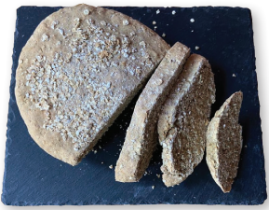

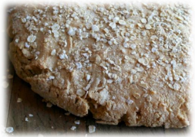

**Agreed outcome:**

Viking Soda Bread

Many countries have traditional dishes. For example:

India is known for hot curries, whilst England is known for the fish ‘n’ chips, which were historically served in newspaper.